Analytics REST API Design

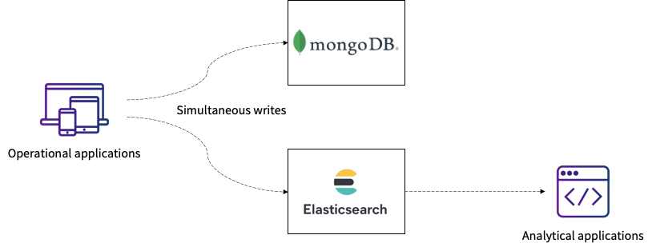

High level System Design:

Loads csv data to both mongo db and to elastic search

And while querying data for analysis purpose we can take data from Elastic search

Technology Stack Used :

1.Node js and express framework for for Api implementation

2.MongoDb datastore

3.Elastic search for Aggregation queries

#for running app you will need node js installed,elastic search and mongo db installed

You start app by running -

Npm install for installing dependencies.

Npm start for starting the app.

Api Endpoints:

1.<http://locahost:8080/>load - reads csv file and bulk insert into mongoDb - GET API

2.<http://locahost:8080/>loadCsvToEdb -reads csv file and bulk insert intoElastic search - POST API

3.<http://localhost:8080/getbySession> - return docs by taking action ,from_date,to_date,brand on mongoDb - GET API

Body parameters:

{

"action":"SESSION_INIT",

"from_time":"2019-03-05T19:07:02Z",

"to_time":"2019-03-05T19:20:04Z",

"brand":"unilever"

}

4.<http://localhost:8080/searchbySession> - GET API

return UNIQUE shoppers with action SESSION_INIT

For date range -on Elastic search

Body parameters example:

{

"brand":"unilever",

"date_fro":"2019-03-05T02:03:02Z",

"date_to":"2019-03-05T02:09:10Z"

}

5.<http://localhost:8080/getuniqueinitUsers>: GET API

return UNIQUE shoppers with action SESSION_INIT for given date range

-on mongo db

Body parameters :

{

"from_time":"2019-03-05T02:03:02Z",

"to_time":"2019-03-05T02:09:10Z",

"brand":"unilever"

}

6. <http://localhost:8080/addShopperlog> - POST API :

Add single schema to both mongoDb and ElasticSearch

Body :

{

"indexName":"users_session_logs3",

"action": "CAMPAIGN_VIEW",

"time_stamp": "2019-03-05T00:01:47Z",

"campaign_id": "13405",

"publisher_id": "molto",

"product_id": "NULL",

"shopper_id": "622561272487DF849B12222836968EE6",

"hashed_ip": "19FBC651BB14FF59DF79AA20E08A2E65",

"user_agent": "Mozilla/5.0 (Linux; Android 8.1.0; SAMSUNG SM-J730G Build/M1AJQ) AppleWebKit/537.36 (KHTML, like Gecko) SamsungBrowser/8.2 Chrome/63.0.3239.111 Mobile Safari/537.36",

"aff_source": "ULTRA_YouTube",

"aff_medium": "Video",

"aff_term": "Trueview",

"aff_campaign": "Skippable-15s",

"aff_content": "L_Tiffany_Jan2019_ID1922",

"parent_org": "unilever"

}